Ex no: 10

Date:

**Cursor – implicit and explicit**

**AIM:**

To create a table employee and to insert 30 records. Also implement the above cursor concepts.

1. **To create table employee:**

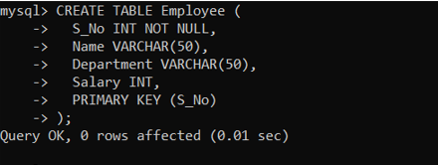

1. **To insert 30 records:**

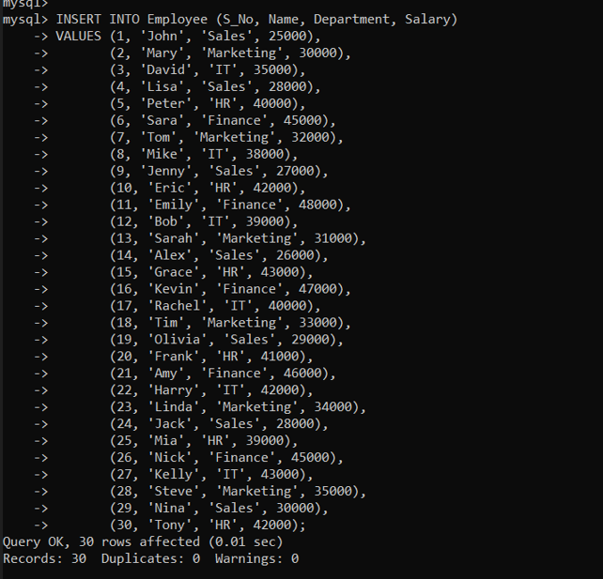

1. **To implement cursor functions:**

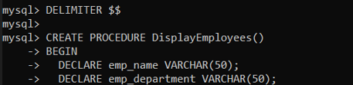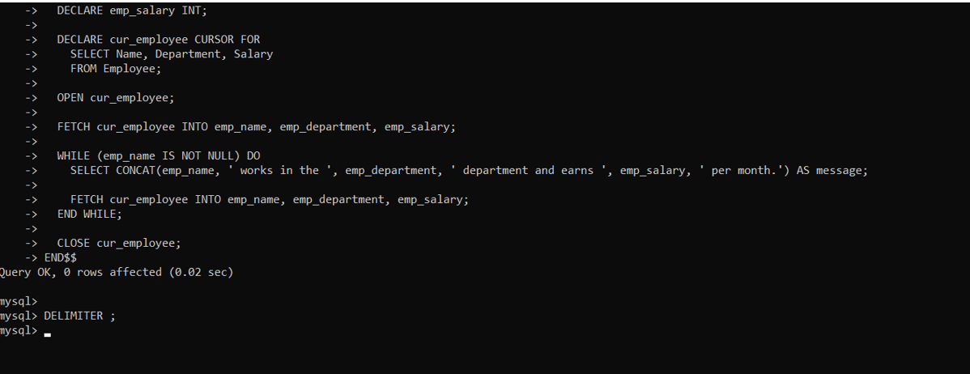

**Result:**

Employee table is created and cursor functions are implemented.